**A**

**Project Report**

**On**

**“IOT based Smoke Detection system”**

**Prepared by:**

Jeet Patel (16IT075)

Daksh Mangukiya (16IT051)

**Under the supervision of**

Prof. Nirav Bhatt

A Report Submitted to

Charotar University of Science and Technology

for Partial Fulfillment of the Requirements for the

Degree of Bachelor of Technology

in Information Technology

IT345 Software Group Project-II (5th sem)

**Submitted at**



**DEPARTMENT OF INFORMATION TECHNOLOGY**

**Chandubhai S. Patel Institute of Technology**

**At: Changa, Dist: Anand – 388421**

**October 2018**



**CERTIFICATE**

This is to certify that the report entitled **“IOT based smoke detection system"** is a bonafied work carried out by **Daksh Mangukiya (16IT051) and Jeet Patel (16IT072)** under the guidance and supervision of **Prof. Nirav Bhatt** for the subject **Software Group Project-II (IT345)** of **5th** Semester of Bachelor of Technology in **Information Technology** at Faculty of Technology & Engineering – CHARUSAT, Gujarat.

To the best of my knowledge and belief, this work embodies the work of candidate herself, has duly been completed, and fulfills the requirement of the ordinance relating to the B.Tech. Degree of the University and is up to the standard in respect of content, presentation and language for being referred to the examiner.

|  |
| --- |
| Under supervision of,  Prof. Nirav Bhatt  Assistant Professor  Dept. of Information Technology  CSPIT, Changa, Gujarat. |
| Prof. Parth Shah  Head & Associate Professor  Department of Information Technology  CSPIT, Changa, Gujarat. |

**Chandubhai S Patel Institute of Technology**

At: Changa, Ta. Petlad, Dist. Anand, PIN: 388 421. Gujarat

TABLE OF CONTENTS

* Acknowledgement 5
* Abstract 6
* Chapter 1 Introduction 7

1.1 Project Summary 7

1.2 Scope 7

1.3 Objective 7

* Chapter 2 System Requirements Study 9

2.1 User Characteristics 9

2.2 Tools & Technology Used 9

* Chapter 3 System Design 10

3.1 Project Flow 10

* Chapter 4 Implementation Planning 11

4.1 Implementation Environment (Single vs Multi user, GUI vs Non GUI) 11

4.2 Coding Standards 11

4.3 Snapshots of project 12

* Chapter 5 Limitations and Future Enhancement 14
* Chapter 6 Conclusion 15
* References 16

**LIST OF FIGURES**

|  |  |
| --- | --- |
| Fig. 4.3.1 ....………………………………………………………………………………… | 12 |
| Fig. 4.3.2 ....………………………………………………………………………………… | 12 |
| Fig. 4.3.3 ....………………………………………………………………………………… | 13 |
| Fig. 4.3.4 ....………………………………………………………………………………… | 13 |
| Fig. 4.3.5 ....………………………………………………………………………………… | 14 |
| Fig. 4.3.6 ....………………………………………………………………………………… | 14 |
| Fig. 4.3.7 ....………………………………………………………………………………… | 15 |
| Fig. 4.3.8 ....………………………………………………………………………………… | 15 |
| Fig. 4.3.9 ....………………………………………………………………………………… | 16 |
| Fig. 4.3.10 ......……………………………………………………………………………… | 16 |

**ACKNOWLEDGEMENT**

Hereby thanking my torchbearers with an immense pleasure who have helped me and stood with me through this project.

My first and foremost thanking goes to my subject faculty Prof. Niarv Bhatt sir for giving me time to solve my problems and help me collecting the resources of my project.

Now I would like to forward my thanking to Prof.Parth Shah, Head of Information Technology Department, Charotar institute of Technology.

Jeet Patel (16IT075)

Daksh Mangukiya (16IT051)

**ABSTRACT**

In this project, first the MQ2 sensor will detect the smoke then the reading which is voltage will go in the arduino board.After the smoke is detect then the buzzer will start.After the buzzer goes on then the it will go to the GSM module.when in GSM module there will be a sim card using which it will send a message on to the mobile phone .

**CHAPTER- 1: INTRODUCTION**

**1.1: Description**

A smoke detector is a device that senses smoke, typically as an indicator of fire. Commercial security devices issue a signal to a fire alarm control panel as part of a fire alarm system, while household smoke detectors, also known as smoke alarms, generally issue a local audible or visual alarm from the detector itself.

**1.2: Purpose:**

The purpose of this project is to help people so that they can know if there is any fire going near by them or in there house.

**1.3: Scope:**

The scope of this project is to design a circuit for smoke detection. It activates an alarm when a substantive quantity of smoke is sensed. Hence, it does not primarily indicate the presence of fire.

**1.4: Objective:**

* The main objective of this project is to design a circuit useful for detecting smoke and activating an alarm. To achieve this, the following must be done:
* Analysis and calibration of MQ2 smoke sensor.
* Development of program to convert the analog output of the sensor to equivalent digital form in the microcontroller.
* Development of audio warnings (buzzer) to indicate the presence of smoke.

**CHAPTER- 2: SYSTEM REQUIREMENTS**

**2.1: User Characteristics:**

User must know how to operate basic android smart phone and if user is member of this school then user must have its own ID and password for login.

**2.2: Tools and Languages Used (For Development)**:

**Software requirement:**  arduino uno

**Hardware requirement:**

1. **MQ2 sensor:**

The MQ-2 is a flammable gas and smoke sensor detects the concentrations of combustible gas in the air and outputs its reading as an analog voltage.The MQ-2 gas sensor is sensitive to LPG, i-butane, propane, methane, alcohol, Hydrogen and smoke. They are used in gas leakage detecting equipments in family and industry and in portable gas detector.

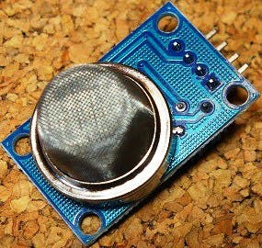

1. **Arduino board:**

Arduino board designs use a variety of microprocessors and controllers. The boards are equipped with sets of digital and analog [input/output](https://en.wikipedia.org/wiki/Input/output" \o "Input/output) (I/O) pins that may be interfaced to various expansion boards or [breadboards](https://en.wikipedia.org/wiki/Breadboards" \o "Breadboards) (*shields*) and other circuits. The boards feature serial communications interfaces, including [Universal Serial Bus](https://en.wikipedia.org/wiki/Universal_Serial_Bus" \o "Universal Serial Bus) (USB) on some models, which are also used for loading programs from personal computers. The microcontrollers are typically programmed using a dialect of features from the programming languages [C](https://en.wikipedia.org/wiki/C_(programming_language)" \o "C (programming language)) and [C++](https://en.wikipedia.org/wiki/C++" \o "C++). In addition to using traditional [compiler](https://en.wikipedia.org/wiki/Compiler" \o "Compiler) [toolchains](https://en.wikipedia.org/wiki/Toolchains" \o "Toolchains), the Arduino project provides an [integrated development environment](https://en.wikipedia.org/wiki/Integrated_development_environment" \o "Integrated development environment) (IDE) based on the [Processing](https://en.wikipedia.org/wiki/Processing_(programming_language)" \o "Processing (programming language)) language project.

1. **Buzzer:**

A **buzzer** or **beeper** is an [audio](https://en.wikipedia.org/wiki/Sound" \o "Sound) signalling device,[[1]](https://en.wikipedia.org/wiki/Buzzer" \l "cite_note-1) which may be [mechanical](https://en.wikipedia.org/wiki/Machine" \o "Machine), [electromechanical](https://en.wikipedia.org/wiki/Electromechanics" \o "Electromechanics), or [piezoelectric](https://en.wikipedia.org/wiki/Piezoelectricity" \o "Piezoelectricity) (*piezo* for short). Typical uses of buzzers and beepers include [alarm devices](https://en.wikipedia.org/wiki/Alarm_devices" \o "Alarm devices), [timers](https://en.wikipedia.org/wiki/Timer" \o "Timer), and confirmation of user input such as a mouse click or keystroke.

1. **LED Light:** Red LED and BLUE LED
2. **GSM module:**

GSM is a mobile communication modem; it is stands for global system for mobile communication (GSM). The idea of GSM was developed at Bell Laboratories in 1970.  It is widely used mobile communication system in the world. GSM is an open and digital cellular technology used for transmitting mobile voice and data services operates at the 850MHz, 900MHz, 1800MHz and 1900MHz frequency bands.

GSM system was developed as a digital system using time division multiple access (TDMA) technique for communication purpose. A GSM digitizes and reduces the data, then sends it down through a channel with two different streams of client data, each in its own particular time slot. The digital system has an ability to carry 64 kbps to 120 Mbps of data rates.

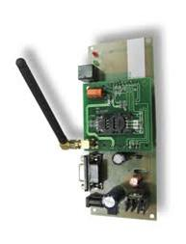

**CHAPTER-3: SYSTEM DESIGN**

**3.1: Project Flow:**

**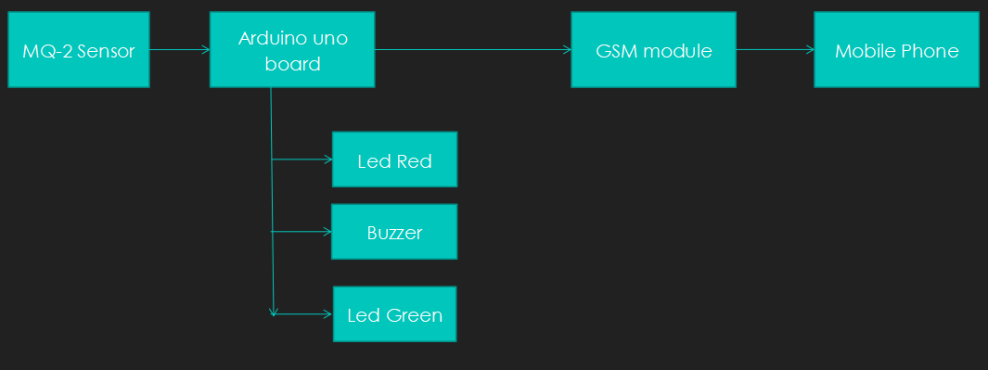**

**CHAPTER- 4: IMPLEMENTATION PLANNING**

**4.1: Implementation Environment:**

**Arduino uno**

**4.2: Coding Standards**

int redLed = 12;

int blueLed = 11;

int buzzer = 13;

int smokeA0 = A3;

// Your threshold value

int sensorThres =30;

void setup() {

pinMode(redLed, OUTPUT);

pinMode(blueLed, OUTPUT);

pinMode(buzzer, OUTPUT);

pinMode(smokeA0, INPUT);

Serial.begin(9600);

}

void loop(){

int analogSensor = analogRead(smokeA0);

Serial.print("Pin A0: ");

Serial.println(analogSensor);

if (analogSensor > sensorThres)

{

digitalWrite(redLed, HIGH);

digitalWrite(blueLed, LOW);

tone(buzzer, 1000, 200);

}

else

{

digitalWrite(redLed, LOW);

digitalWrite(blueLed, HIGH);

noTone(buzzer);

}

GSM CODING:

#include <SoftwareSerial.h>

SoftwareSerial mySerial(9, 10);

void setup()

{

mySerial.begin(9600); // Setting the baud rate of GSM Module

Serial.begin(9600); // Setting the baud rate of Serial Monitor (Arduino)

delay(100);

}

void loop()

{

if (Serial.available()>0)

switch(Serial.read())

{

case 's':

SendMessage();

break;

case 'r':

RecieveMessage();

break;

}

if (mySerial.available()>0)

Serial.write(mySerial.read());

}

void SendMessage()

{

mySerial.println("AT+CMGF=1"); //Sets the GSM Module in Text Mode

delay(1000); // Delay of 1000 milli seconds or 1 second

mySerial.println("AT+CMGS=\"+919427056929\"\r"); // Replace x with mobile number

delay(1000);

mySerial.println("I am SMS from GSM Module");// The SMS text you want to send

delay(100);

mySerial.println((char)26);// ASCII code of CTRL+Z

delay(1000);

}

**4.3: Snapshots of project:**

**4.3.1:**

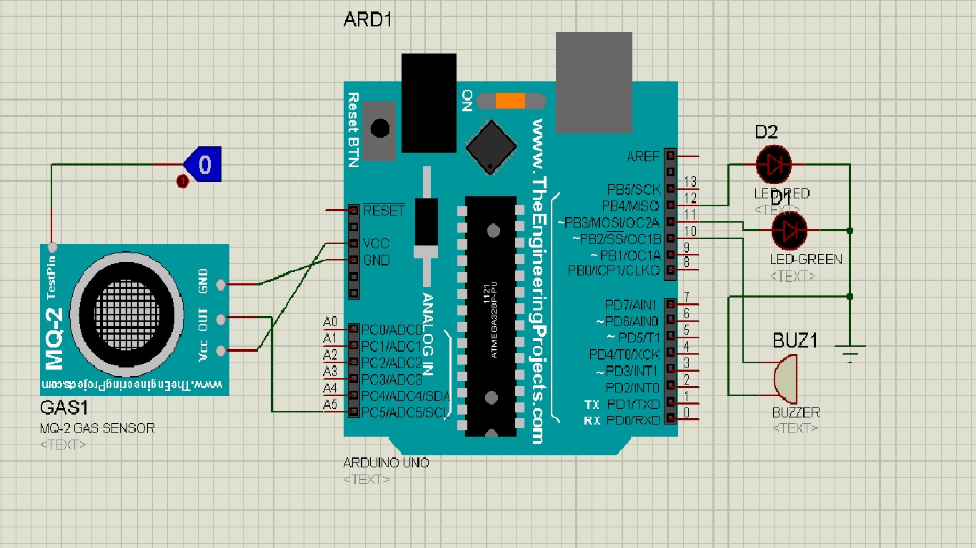

**4.3.2:**

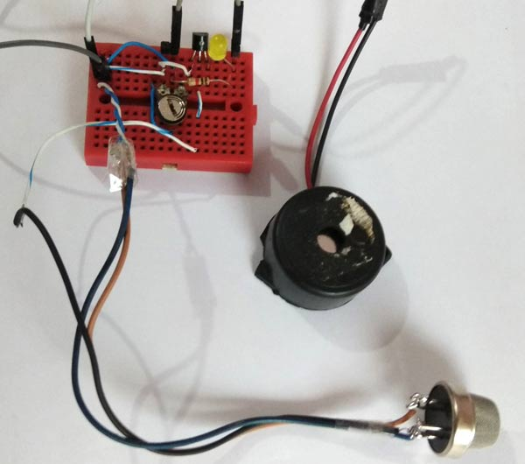

**CHAPTER-5: LIMITATIONS AND FUTURE ENHANCEMENT**

**5.1: Limitations**

* It would not detect other harmful gases like Sulphur Dioxide, Greenhouse gases and many more such gases
* Even in case of non-harmful gases the sensor would activate the buzzer
* Will not work in humid condition
* No provision to detect the type of gas in air

**5.2: Future Enhancements**

- We can add a Humidity Sensor in future so that the system would shut itself down in extreme humid conditions.

- Other features can be included like automatic opening of windows and start off water sprinklers during high smoke levels or automatic switching on the Exhaust fan.

**CHAPTER 6: CONCLUSION**

**6.1: Conclusion**

smoke detection is on of the easiest and low costly.most of the industry use it because it works falty to protect and most effective.in future the use gas and smoke will we more so the use of this device will be more effective.

**6.2: References**

* "https://en.m.wikipedia.org/wiki/Smoke\_detector," [Online].
* J. Milke, "History of Smoke Detection: A profile of how the technology and role of smoke detection has changed".
* "www.madehow.com/Volume-2/Smoke-Detector.html," [Online].